Assignment No: 01



Department of Computer Science

Iqra University Islamabad

Maqsood Ahmed

ID: 38186

**The Illumination of the Medieval World: Avicenna, Averroes, and Rumi**

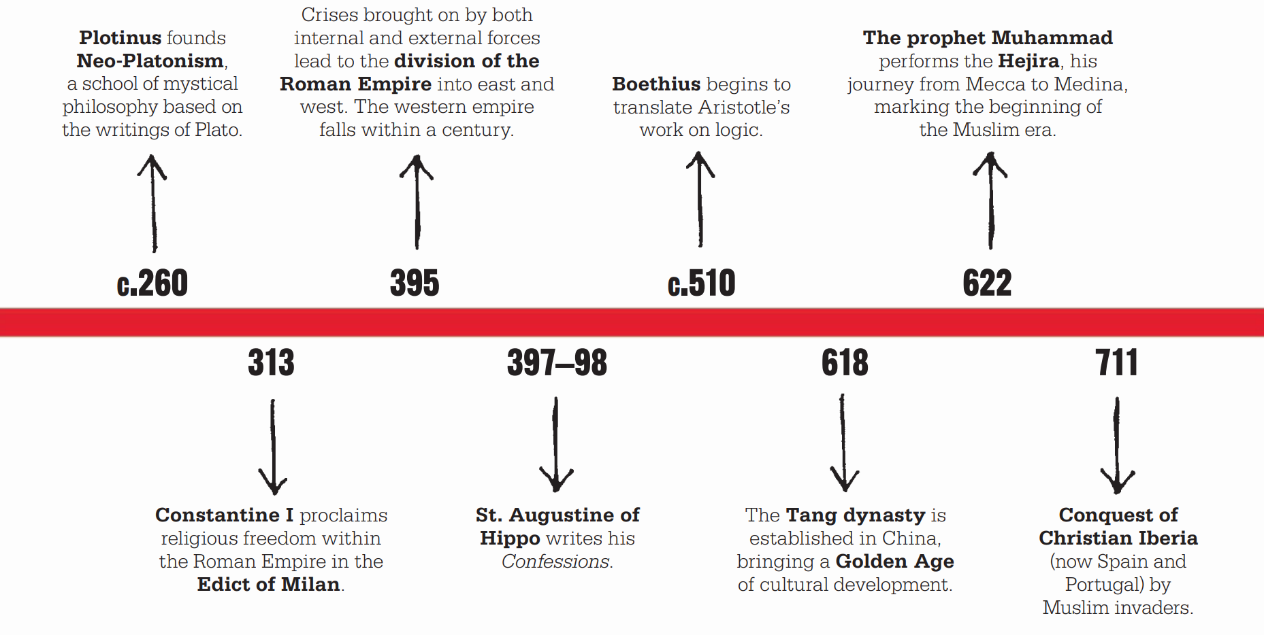

The Medieval World, spanning roughly from 250 to 1500 CE, witnessed a flourishing of philosophical inquiry, particularly in the Islamic world. This era, often termed the Islamic Golden Age, was a period of intense intellectual exchange between Greek, Islamic, and Judaic traditions. Three prominent philosophers emerged from this rich tapestry of thought: Avicenna, Averroes, and Jalal ud-Din Rumi. While sharing some common ground, each thinker offered unique perspectives that continue to influence philosophy today.

**Avicenna (Ibn Sina, 980-1037 CE):** A polymath from Central Asia, Avicenna was a physician, scientist, and philosopher whose work left an indelible mark on Islamic thought and beyond. He was a proponent of **Aristotelianism**, integrating it with Islamic theology. One of his central themes was the concept of existence and essence. He argued that essence is the defining characteristic of a thing, while existence is the act of being. For example, the essence of a human is rationality, but existence is the particular living human being. This distinction had a profound impact on subsequent philosophical discussions.

Another significant contribution of Avicenna was his exploration of the **nature of the soul**. He differentiated between the rational soul, which allows for intellectual understanding and is immortal, and the animal soul, which is responsible for bodily functions and is perishable. This concept resonated with Christian thinkers like Aquinas, who later developed his own theory of the soul.

**Averroes (Ibn Rushd, 1126-1198 CE):** A Spanish philosopher of Arab descent, Averroes was a key figure in interpreting and disseminating the works of Aristotle in the Islamic world. He emphasized the importance of reason and logic in understanding the universe. Unlike Avicenna, who attempted to reconcile philosophy with religion, Averroes believed there could be truths revealed through philosophy that differed from religious doctrines. This concept, known as the **doctrine of the double truth**, sparked controversy as it challenged the authority of religious interpretations.

Averroes' views on the **immortality of the soul** were another point of contention. He argued that only the universal intellect, which is shared by all humans, is immortal. Individual souls, according to him, are not. This position conflicted with Islamic teachings on the afterlife and further strained the relationship between philosophy and theology.

**Jalal ud-Din Rumi (1207-1273 CE):** A mystic poet and theologian from Persia, Rumi occupies a unique space in Islamic thought. Unlike the more rationalist approaches of Avicenna and Averroes, Rumi emphasized **love, intuition, and spiritual experience** as paths to truth. His most famous work, the *Mathnavi*, is a collection of poems exploring themes of divine love, self-discovery, and the unity of existence.

Rumi's concept of **Wahdat al-Wujud** (Unity of Being) posits that all creation is a manifestation of the divine. This challenges the idea of God as a separate entity and emphasizes the interconnectedness of all things. Rumi's mystical approach resonated deeply with people across cultures and religious backgrounds, making him one of the most influential spiritual figures in history.

**Comparing the Philosophers:**

* **Reason vs. Revelation:** While Avicenna and Averroes placed a high value on reason and logic, Rumi emphasized intuition and spiritual experience. Avicenna attempted to reconcile reason with faith, while Averroes saw potential contradictions. Rumi transcended this debate by focusing on a unitive experience of the divine that goes beyond the limitations of reason.
* **Nature of the Soul:** Avicenna's distinction between the rational and animal souls laid the groundwork for later discussions. Averroes' view of the non-immortality of the individual soul differed from prevailing Islamic beliefs. Rumi did not dwell on the nature of the soul but focused on its connection to the divine.
* **Impact:** All three thinkers had a lasting impact. Avicenna's work influenced Western philosophers like Aquinas. Averroes' interpretations of Aristotle shaped philosophical discourse for centuries. Rumi's mystical poetry continues to inspire people worldwide.

**Conclusion**

In conclusion, Avicenna, Averroes, and Rumi represent distinct yet complementary strands of thought within the rich tapestry of Medieval philosophy. While Avicenna and Averroes engage in rigorous metaphysical and epistemological inquiries informed by Aristotelian philosophy and Islamic theology, Rumi's mystical perspective offers a profound exploration of the human soul's journey towards spiritual realization and union with the Divine. Despite their differences, these philosophers share a common aspiration to uncover the ultimate truths of existence and guide humanity towards wisdom, virtue, and spiritual fulfillment.

**The End**